**Assignment-2**

**DOMAIN:** IOT

**TOPIC:** SMART WASTE MANAGEMENT SYSTEM FOR METROPOLITAN CITIES

**NAME:** MUKHESH KARAN B.L

**REG NUMBER:** 727819TUCS131

**COLLEGE:** SRI KRISHNA COLLEGE OF TECHNOLOGY

ASSIGNMENT QUESTION:

**Build a python code, assume you get temperature and humidity values (generated with random function to a variable) and write a condition to continuously detect alarm in case of high temperature.**

PYTHON CODE:

import random

import time

while(1!=0):

temperature=random.random()

humidity=random.random()

print("Temperature: ","%.5f"%temperature)

print("Humidity: ","%.5f"%humidity)

time.sleep(2)

if(temperature>0.7):

print("high temperature")

if(humidity>0.7):

print("high humidity")

print("")

EXECUTION RESULT

Program

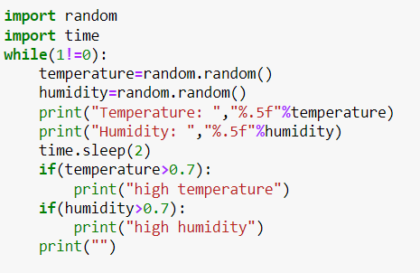

Output

